CSS Exercise

# The objective

The idea of this exercise is that you learn how to use basic transformations and animations in your web site.

# Exercise

Use the mystyle.css file to define the advanced styles in your web page

1. Make a transition that scales the image larger when mouse pointer is hovering it. (there are two ways to do this, try both).

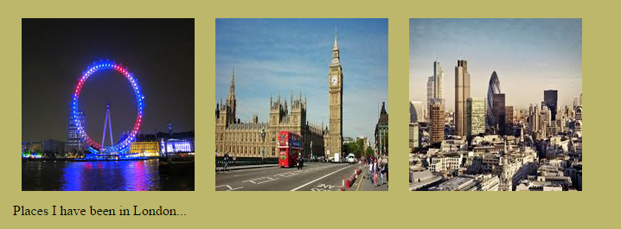

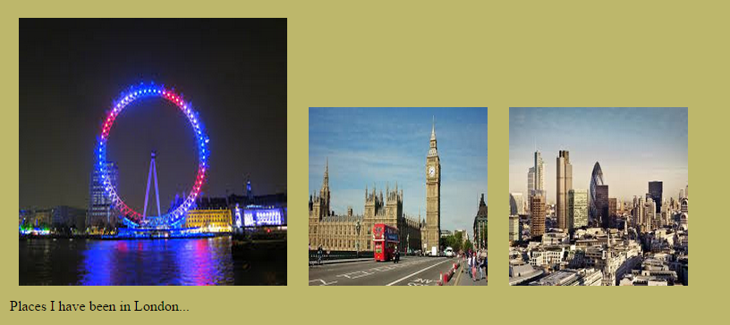

1. Make the list elements rotate 180deg when the mouse pointer is hovering it. Make it so that transition takes 1s.

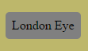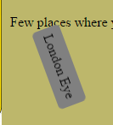

1. Make a little animation where the H1 element text color changes from red to gray in 5s. Use animation key frames and ‘from’ and ‘to’ properties to do this.